

Frankenskate Winter Escapade

Jersey Coast FSC Essex FSC

10/26/2013 January 18, 19, 2014

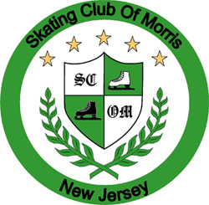

[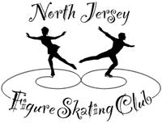](http://www.northjerseyfsc.org/)

Staten Island BS 2/23/2014 Morris Open

Skylands 3/23/2014 March 28, 29, 30, 2014

Ice Vault BS 5/4/2014 Skating Club of Morris

North Jersey FSC

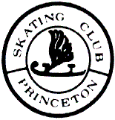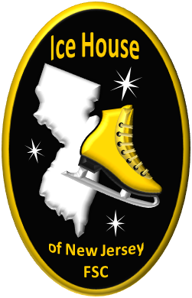 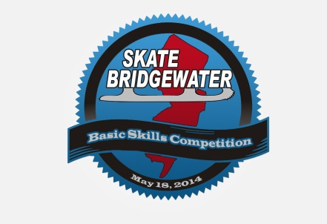

Basic Skills Competition Ice House of NJ FSC BS Skate Bridgewater BS Competition

04/12/2014 04/27/2014 05/18/2014

Princeton Skating Club Ice Hour of New Jersey FSC Skating Club of Bridgewater