HOW TO REGISTER AS A MEMBER IN THE SKATING CLUB OF MORRIS
Drafted May 6, 2014 by Carol Zrybko

- Log in to ENTRYEEZE.com

- Choose OUR MEMBERSHIP CLIENTS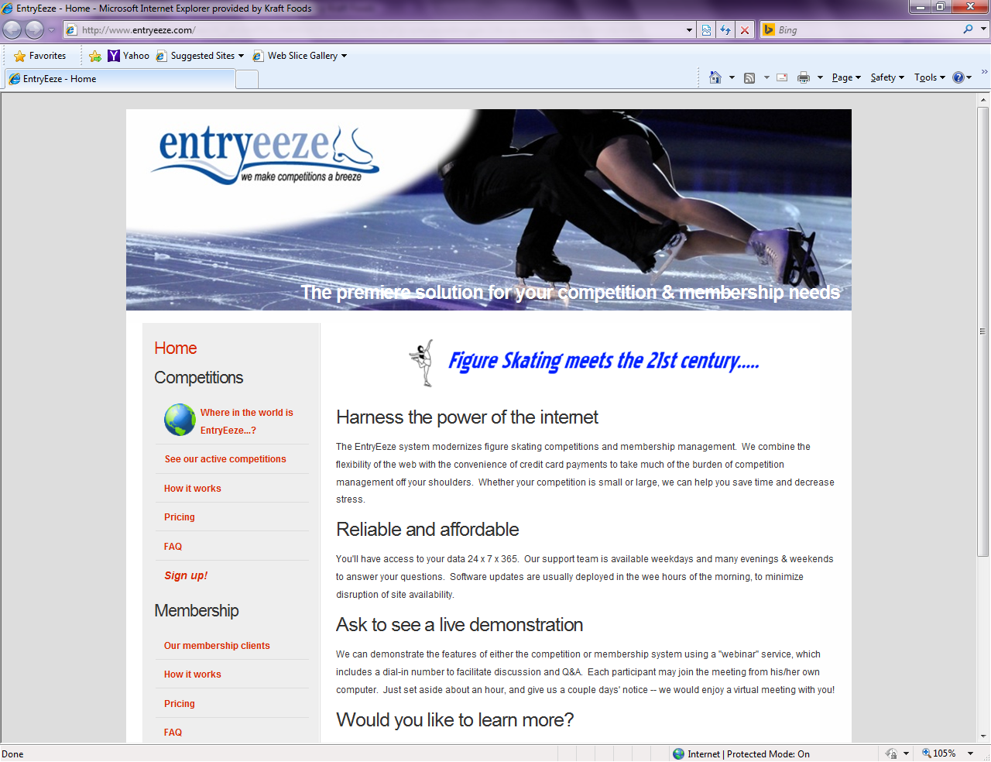

- Scroll down until you see THE SKATING CLUB OF MORRIS logo, then click on it.

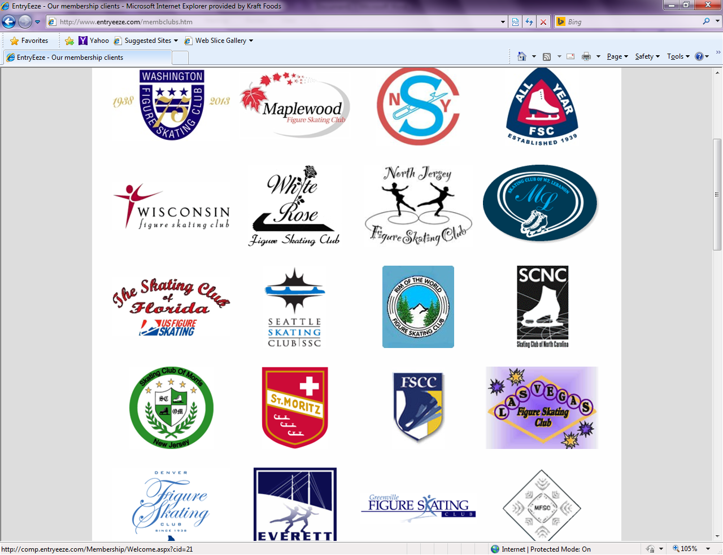

- Log in using your User Name and Password under EXISTING MEMBERS or NEW MEMBERS. For Existing Members, you will need your email address and password. For new members, follow the instructions to create an account.
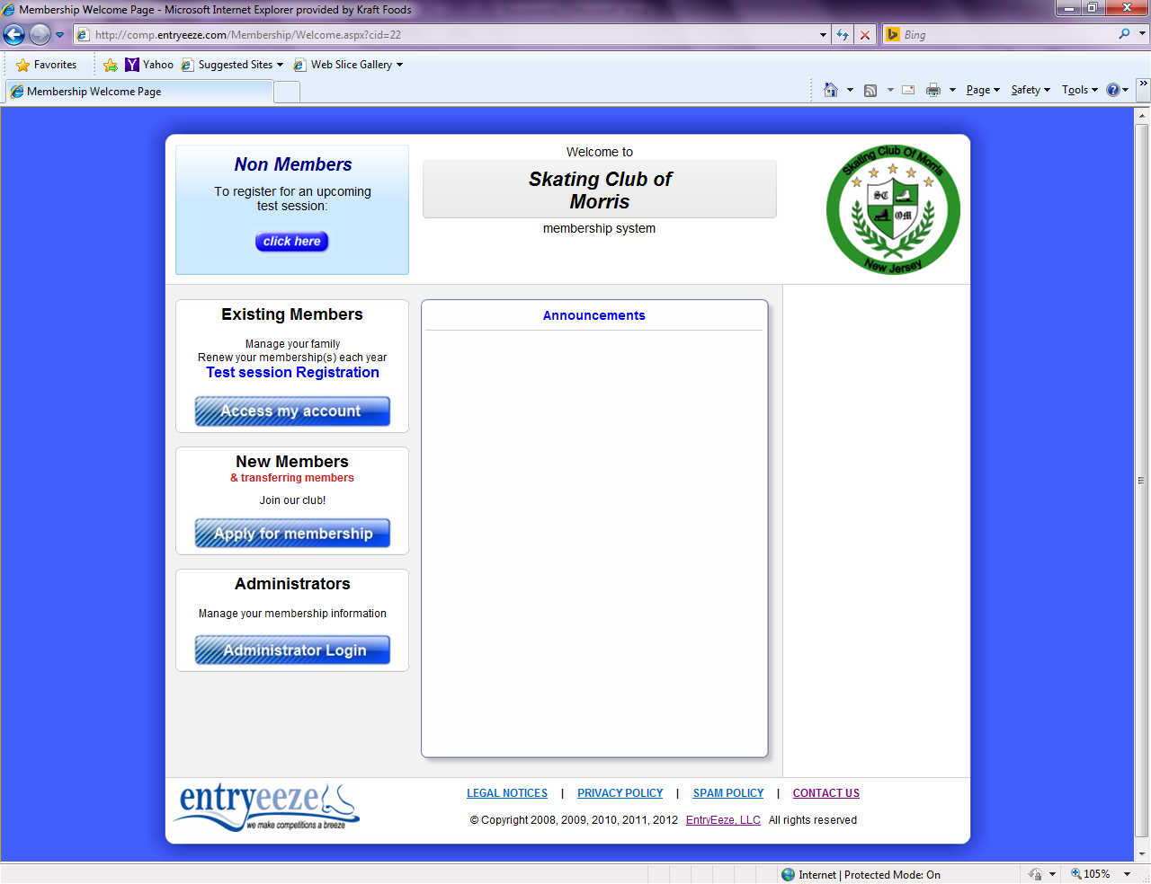

- You will see your PERSONAL INFORMATION. Please check that everything is correct. Then click on APPLY/RENEW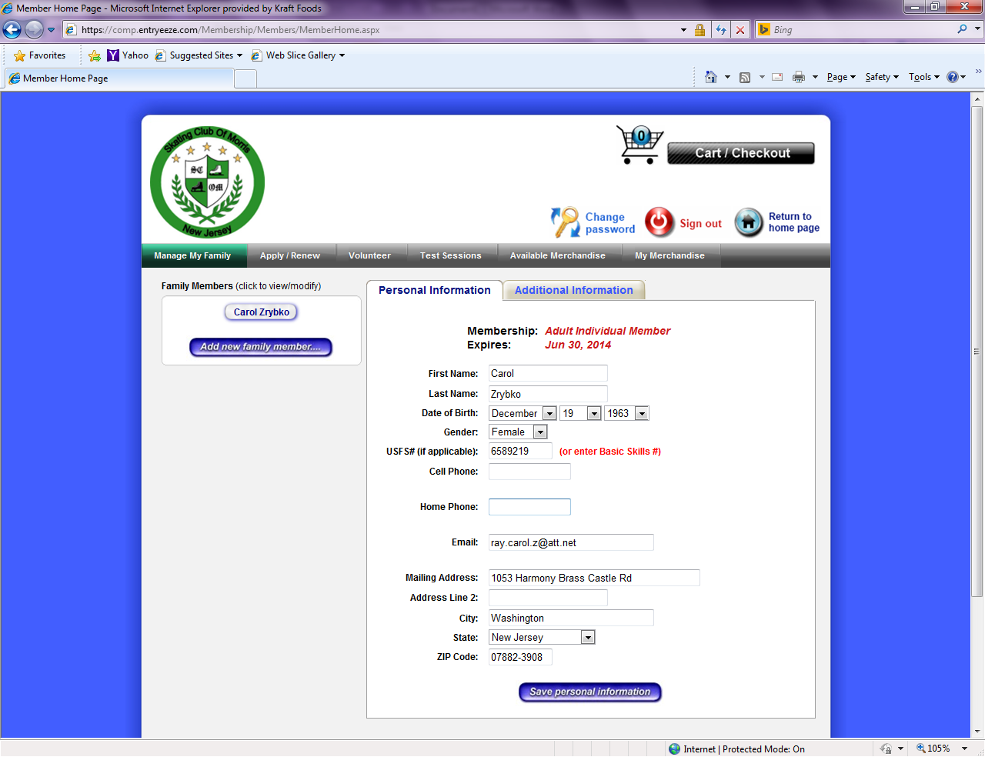

- Choose Membership type from the drop down box and Hit UPGRADE.
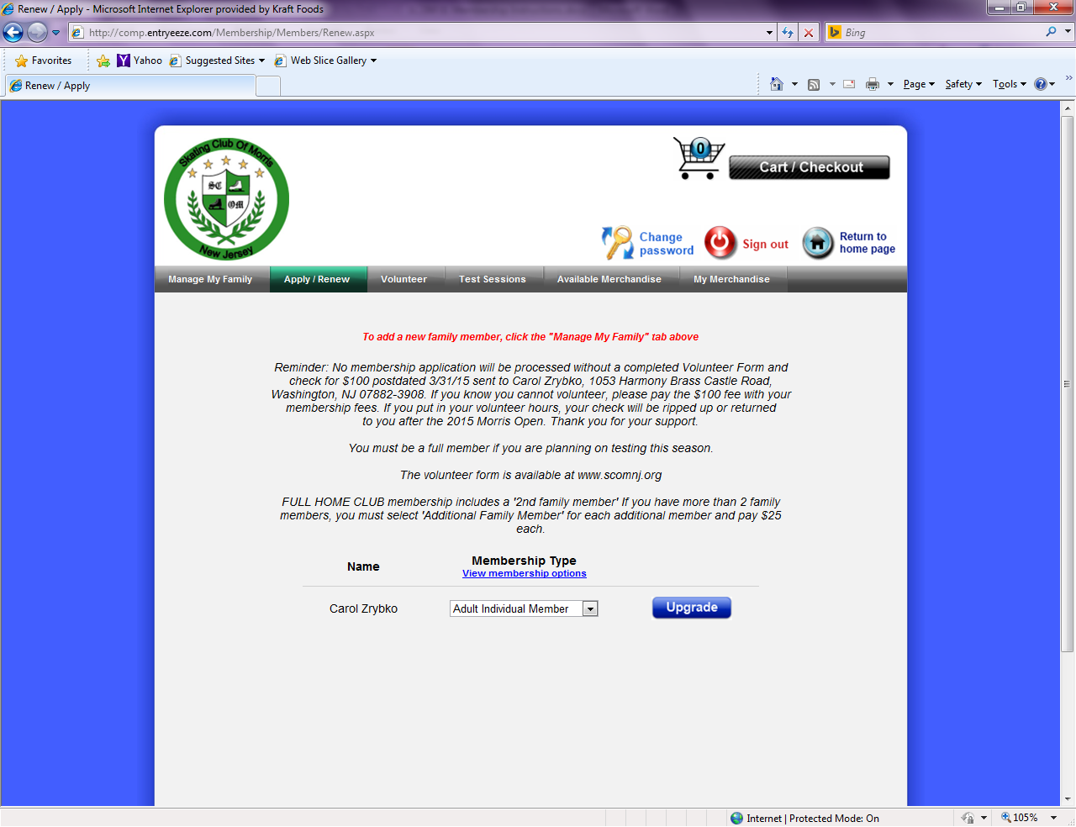
- Please check that the information is correct and hit SAVE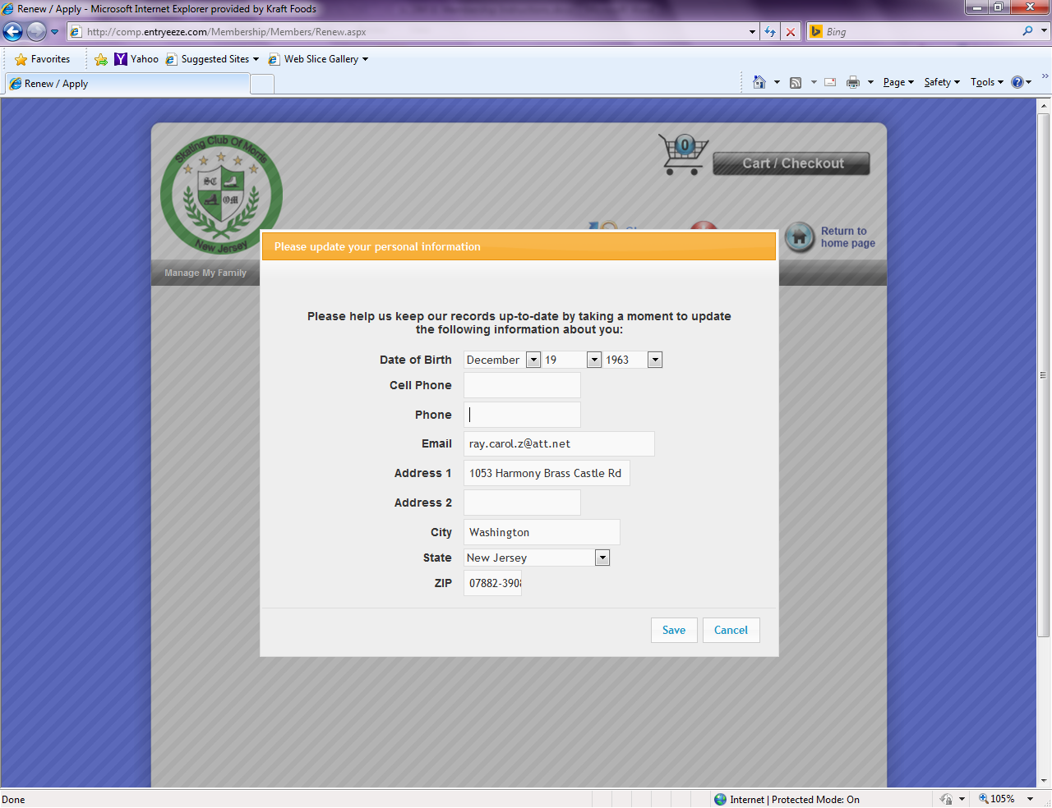

- Read through all the waivers and questions. Type in your name if you consent to what’s being asked in each waiver. If you do not agree, type “I DO NOT AGREE”. Use the arrow along the right side to scroll down and view all the forms. Hit SAVE when done.

NOTE: To simplify the registration process, all forms are now on Entryeeze.

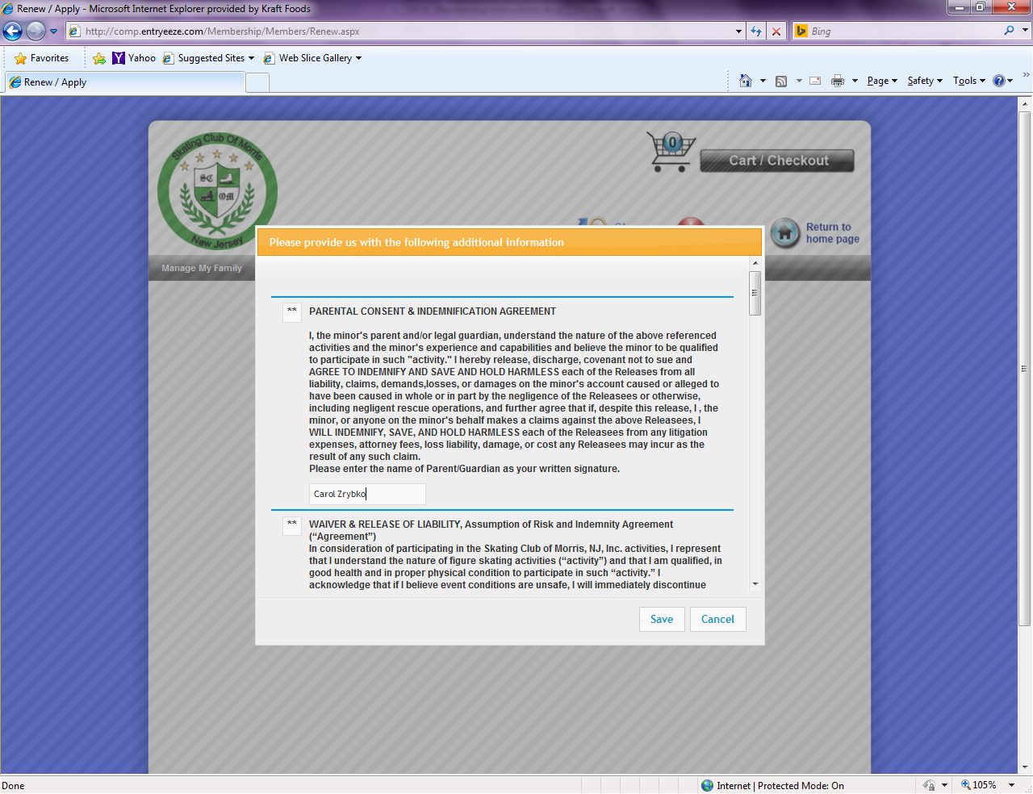

- When done, go to Shopping Cart to complete transaction. 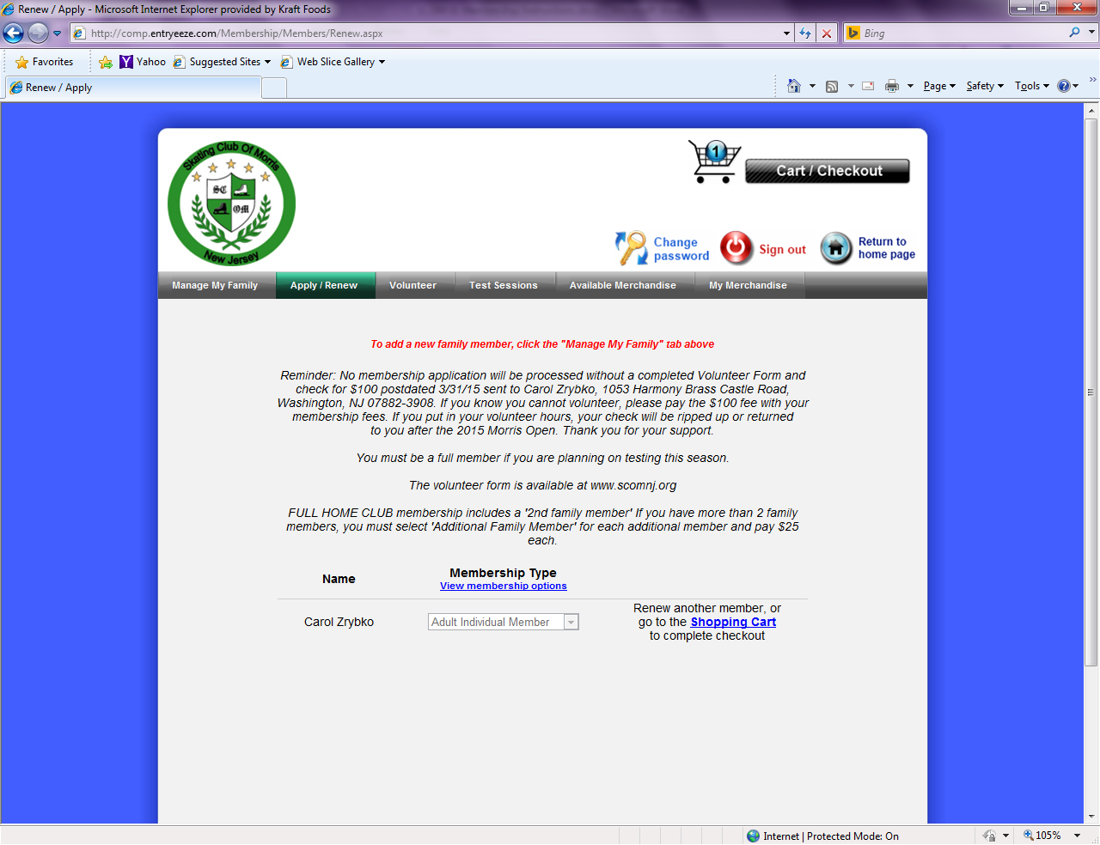
- In the shopping cart, you should see the correct price for the membership type you selected. Also, here is where you can donate $100 in lieu of volunteering the required 4 hours to the Skating Club. Hit CONTINUE CHECKOUT when ready.
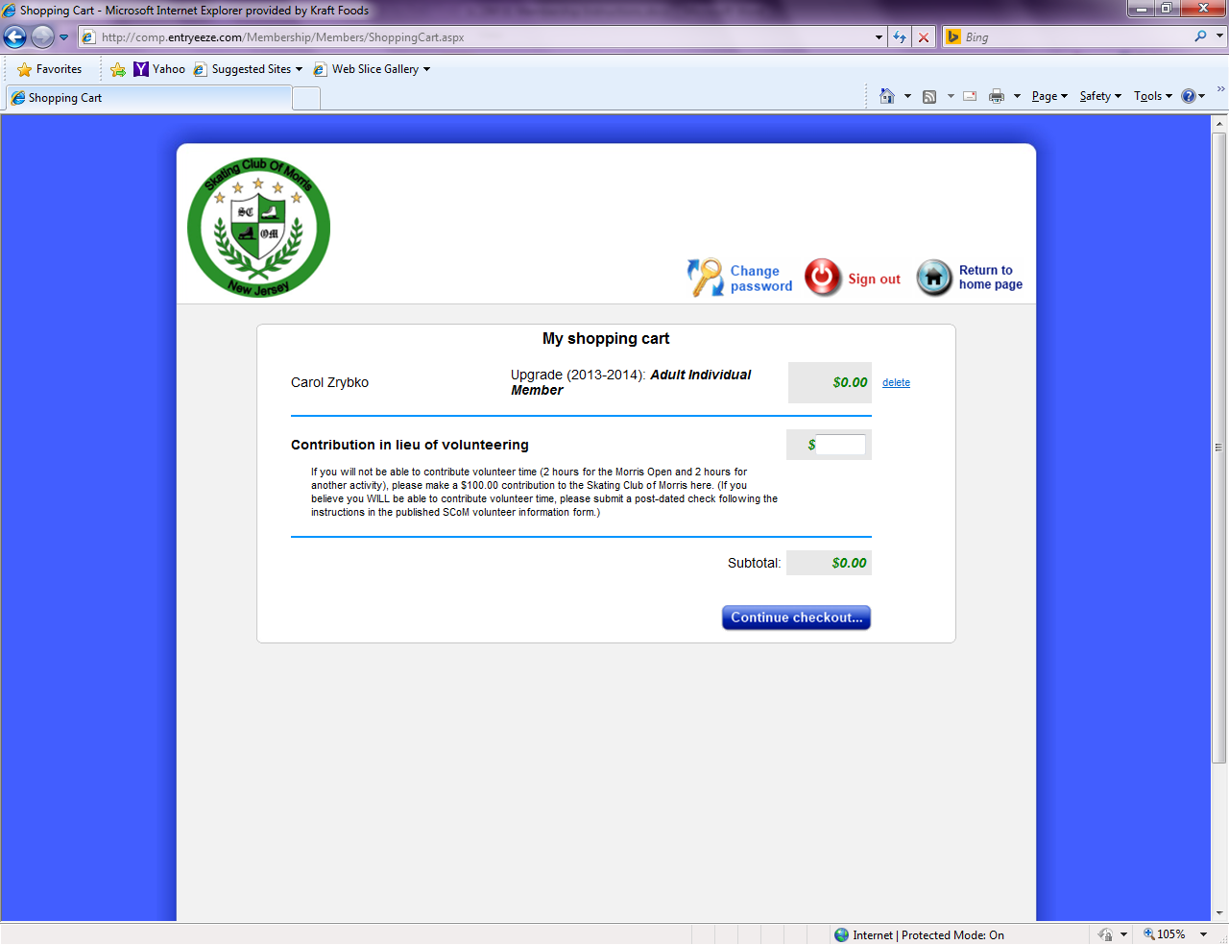
- Check the box that you understand and agree to the terms of the statement. Hit CONTINUE CHECKOUT.

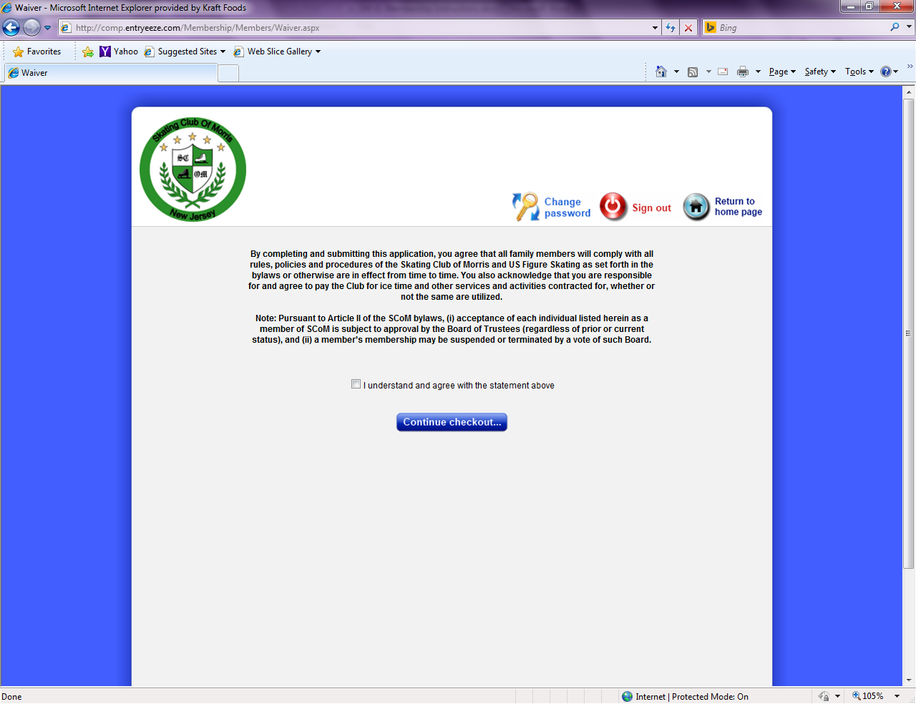
- You will be asked for your credit card information before completing the checkout process. Once done, you will see a confirmation and will receive an email.
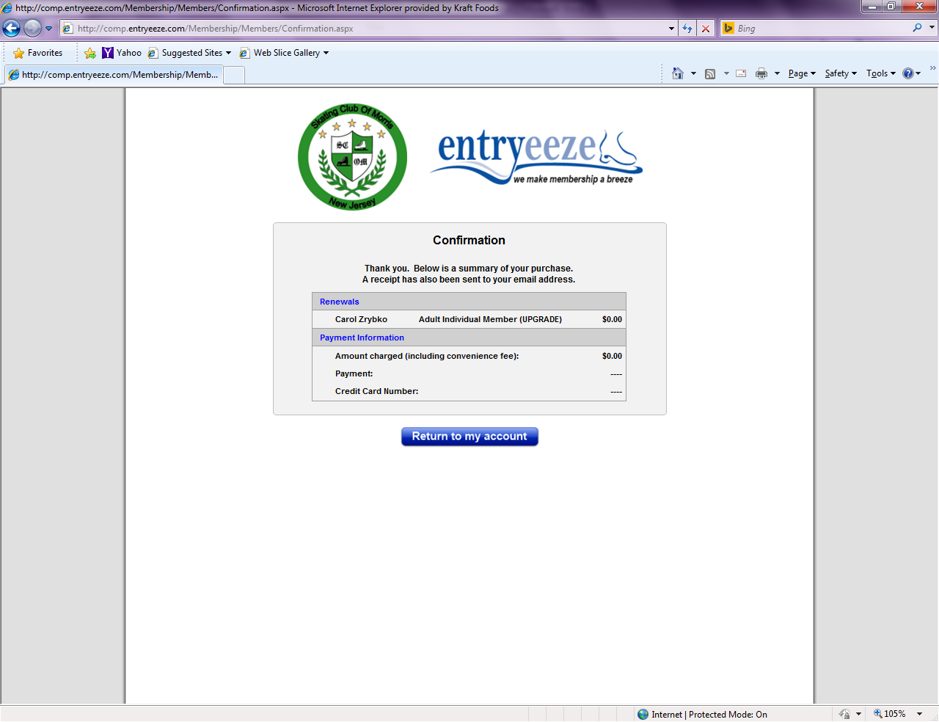
- If you have chosen to volunteer the required 4 hours, you are required to send a post-dated check (March 31, 2018) payable to SCOM in the sum of $100 to Katherine Roekaert Davis, the Membership Chair. This check will be held until after the Morris Open. If you have completed the 4 volunteer hours, your check will either be returned to you or will be destroyed depending on your choice. If you have not completed your 4 volunteer hours, your check will be cashed. NOTE: Your membership will not be processed with USFS until the Membership Chair has received your volunteer check

Your volunteer check can be placed in Katherine’s folder at the rink or sent to:
Katherine Roekaert Davis
7 Moraine Road
Morris Plains, N.J. 07950

- If you have any questions, feel free to send us an email at SCOMnj@gmail.com

